Game Description :

Game Rules:

1-

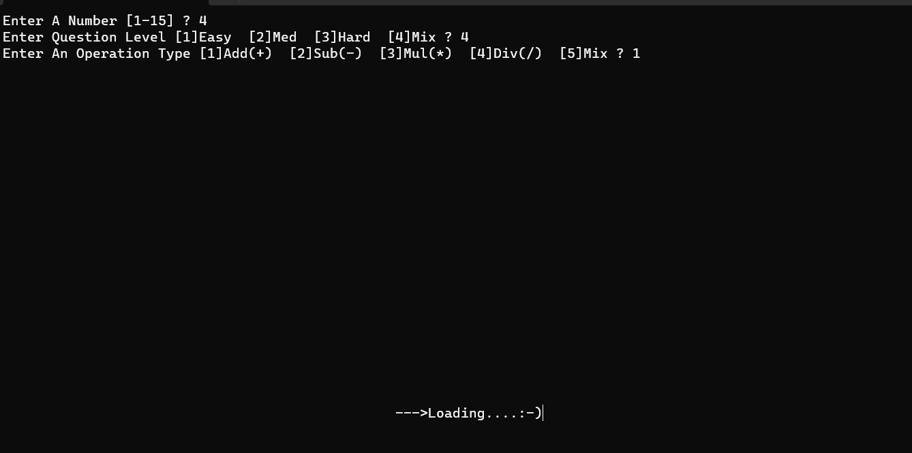

2-Then I Printed Number Of Questions \*One By One\*

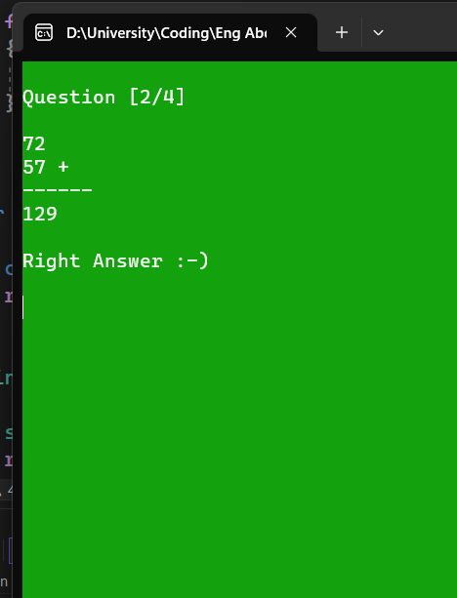

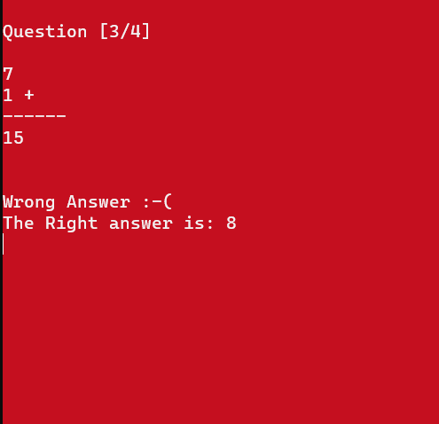

3- Printing The Final Result

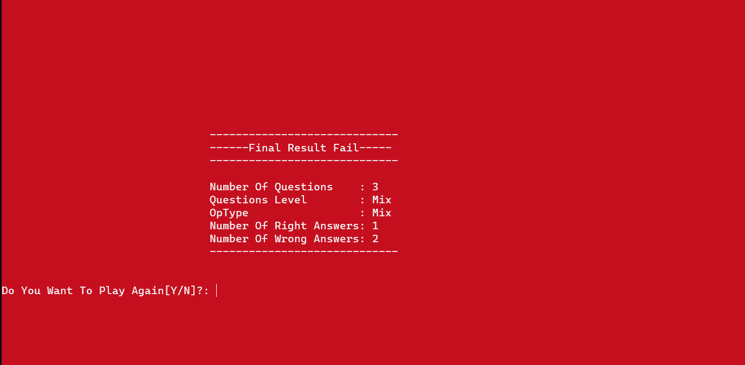

Here I Lost So The BackGround Color Turned To Red

If I Won The BackGround Color would Be Green